PRACTICE EXAM QUESTIONS (I)

1. [6 marks]
Plot P (2,π) and Q (4,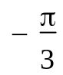 ) and hence, find the exact length of 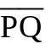.

2. [5, 5 = 10 marks]
a) Find the Cartesian co-ordinates of the point with polar co-ordinates (2, ).

- Transform the Cartesian co-ordinates (1,-1) into polar co-ordinates where 0 < θ ≤ 2π.

PRACTICE EXAM QUESTIONS (I) – SOLUTIONS
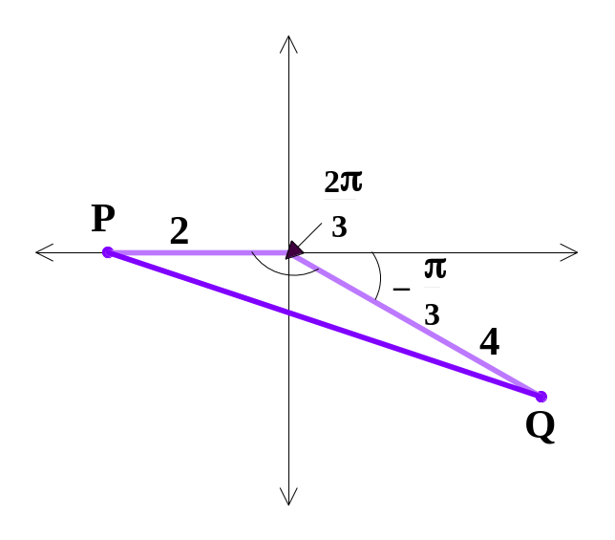
1. 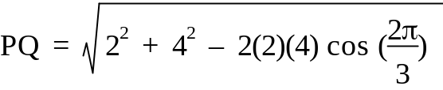 ✓✓ 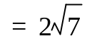 ✓
✓
✓

✓

2. a) For (2, ),
x = r cos θ = 2 cos = 1 ✓✓
y = r sin θ = 2 sin = 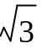 ✓✓
∴ the Cartesian co-ordinates are (1, ). ✓

b) For (1,-1),
r² = x² + y² = 2 ⇒ r = 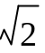 ✓✓
As (1,-1) is in the 4th quadrant, θ must lie in the 4th quadrant. ✓
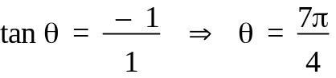 ✓
∴ the polar co-ordinates are ( ,  

